Problem 15

发表于 2002-04-20   |

[**Problem 15**](https://projecteuler.net/problem=15)

**Lattice paths**

Starting in the top left corner of a 2×2 grid, and only being able to move to the right and down, there are exactly 6 routes to the bottom right corner.

[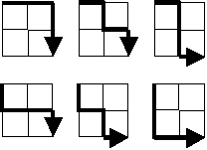](https://projecteuler.net/project/images/p015.gif)

How many such routes are there through a 20×20 grid?

**网格路径**

从一个2×2方阵的左上角出发，只允许向右或向下移动，则恰好有6条通往右下角的路径。

[](https://projecteuler.net/project/images/p015.gif)

对于20×20方阵来说，这样的路径有多少条？